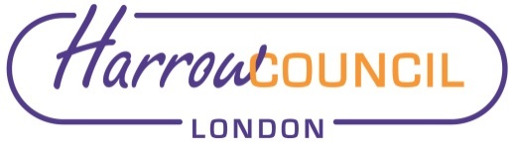

Proposed West Drive and Bellfield Avenue Conservation Area
Consultation Report
April 2023

Table of Contents

1. Introduction
2. Consultation Activities
3. Consultation Findings
4. Conclusion

1. Introduction

1.1 This report details the process and outcomes of the West Drive and Bellfield Avenue Conservation Area consultation undertaken by Harrow Council. The consultation ran for a period of 6 weeks from 20 February 2023 to 3 April 2023.

Project Context (Why was this project initiated?)
Following a review of potential areas for designation as conservation areas in late 2022, Harrow Council has identified West Drive and Bellfield Avenue for potential designation. The Council want to understand what the residents of West Drive and Bellfield Avenue think about designation. It also seeks to understand the views of Historic England, the Government’s advisors on heritage matters.

Project Aims (What does the project hope to achieve?)
The aims of this consultation were to:
- Advise the community about what a potential conservation area designation might mean for them and their neighbours;
- Undertake meaningful, inclusive and transparent consultation to understand the community's views on designating the area a conservation area;
- Use the feedback to help the Council make any final decision whether or not to designate the area as a conservation area, including any changes to the proposed conservation area border;
- Feed back to the community to let them know that we have listened and acted on the information they have provided.

How will the information in this summary report be used?
The information in this report will detail the findings of the consultation and be shown to decision makers within the council. The decision makers will then decide whether to amend the conservation area border, and/or formally designate the area as a conservation area in its current form.

Consultation Materials
Residents of the proposed conservation area were sent letters informing them of the consultation (99 letters in total). These letters included information on the dates, context and ways to get involved in the consultation. QR codes were included on the letters to provide a direct and easy to access link to the engagement platform webpage.

Hard copy site notices (seven) were printed, laminated and placed around the proposed conservation area on streetlamps. The site notices gave a quick summary of the consultation including dates and ways to respond. A QR code was also included on the site notices to provide a direct link to the engagement platform webpage.

2. Consultation Activities

Engagement Platform

2.1 The engagement platform was run through the Council’s My Harrow Talk (Engagement HQ) page. While the page was live it was visited 177 times resulting in 142 aware visitors (visited at least one page), 61 informed visitors (visited multiple pages / downloaded a document) and 11 engaged visitors (completed the survey or asked a question). The page saw the most traffic during early March as shown by the visitor summary timeline below.

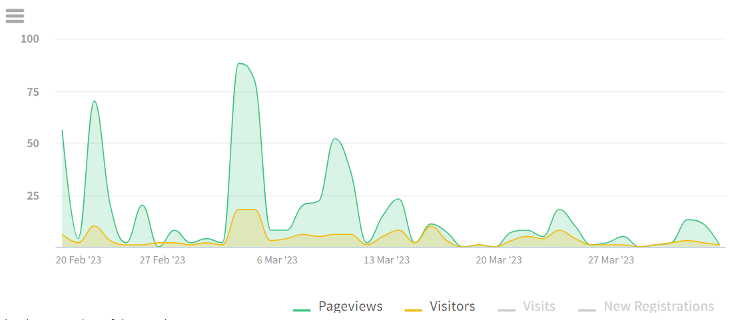
Figure 1: Timeline of engagement platform visitors

2.2 Visits to the page came from a variety of sources. Direct visits accounted for the majority of visits. These likely came from the QR codes on the letters to residents and hard copy site notices. It is worth noting that the council only sought responses from residents who live in the proposed conservation area or immediately abutting it (through the site notices). For this reason, there were no widespread social media or council communications to the whole borough as there usually would be in broader consultations.
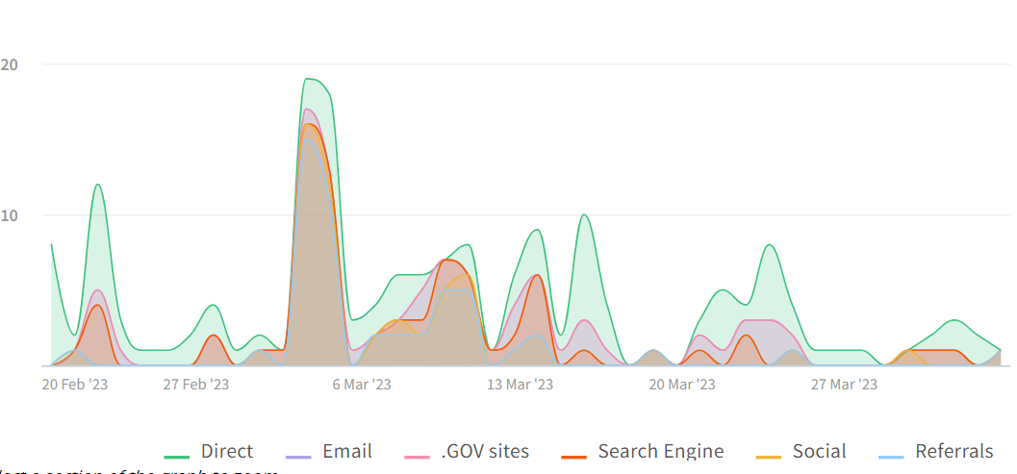
Figure 2: Timeline of page visits with access sources

Survey

2.3 The survey was undertaken by 10 registered users. The survey was constructed to be straightforward and simple to respond to, avoiding unnecessary or confusing questions. Four questions were asked; section 3 documents these and the responses. Participants were required to register in order to respond to the survey, this ensures that the respondents are real people with email addresses. The survey can only be responded to once by each registered user.

Online Workshops

2.4 No workshops / meetings were held for this consultation. Due to the small number of consultees and the straightforward nature of the consultation these were not considered to be appropriate consultation tools in this instance.

Written Submissions

2.5 The Council received six written submissions via email (LDF@harrow.gov.uk) over the consultation period. One written response argued against the inclusion of their property in the conservation area as it was of the same style and era of newer buildings that had been excluded from the proposed conservation area. The inclusion of this property should be examined in further detail. Three written submissions supported the adoption of the conservation area in its current state and expressed concern that the designation was ever removed. One other response objected to the designation of the conservation area on architectural grounds stating that many of the houses have been altered or modernised significantly and no longer reflect the original architectural styles.

2.6 A response was also received from Historic England, who are the Government’s advisors on heritage. They noted that ‘Overall the area is not notable for its local architectural or historic significance’. The response will be addressed in any formal report as to whether designation should proceed.

3. Consultation Findings

Survey Findings

3.1 The survey comprised of four simple ‘Yes or No’ check box questions. The first question asked respondents ‘Do you live in the proposed conservation area?’ The response was mandatory to proceed with the survey. Of the 10 respondents, 8 lived within the conservation area and two did not, stating that they lived nearby. A graph of the responses is shown below.

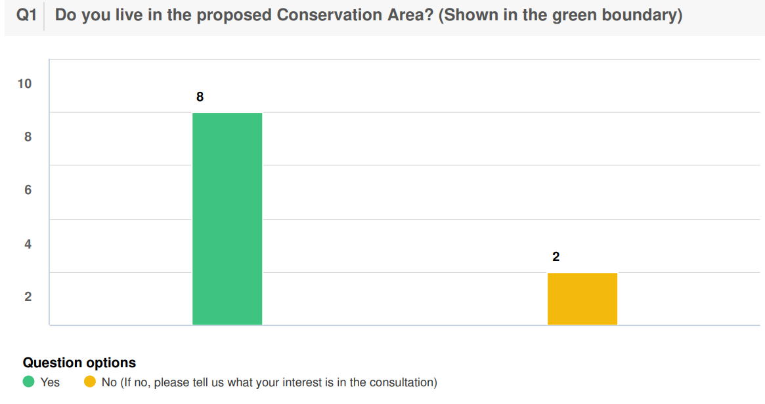

3.2 The second question was also a mandatory question with a ‘Yes or No’ answer. The question asked respondents ‘Do you support the inclusion of West Drive and Bellfield Avenue in a new Conservation Area?’. Of the 10 respondents 8 selected ‘Yes’ in support and 2 selected ‘No’ in opposition. A graph of the responses is shown below.

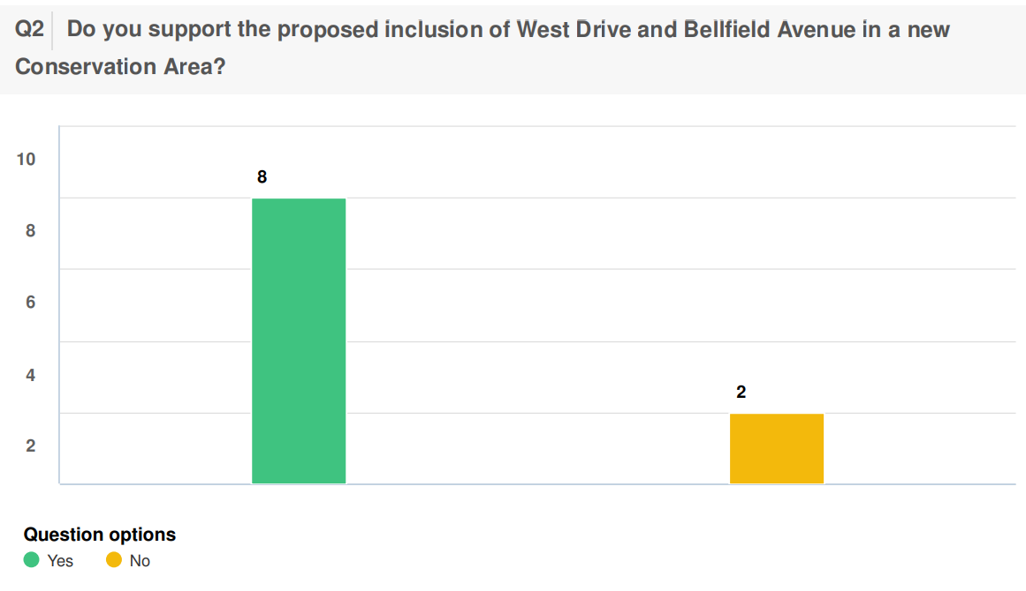

3.3 The third question was also a mandatory question with a ‘Yes or No’ answer. The question asked respondents ‘Noting the criteria for Conservation Areas below, do you agree with the Council’s recommendation to include West Drive and Bellfield Avenue in a conservation area?’ The potential responses were Yes’, ‘No’, ‘No opinion’ and ‘Partially’. Of the 10 respondents 8 responded ‘Yes’ and 2 responded ‘No’. A graph of the responses is shown below.

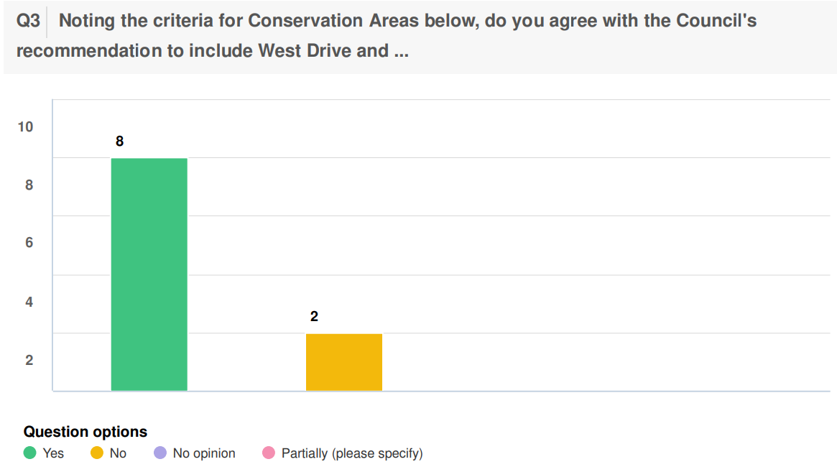

3.4 The final question was not mandatory and asked respondents ‘Do you have any other comments?’. Of the 10 respondents 4 had no additional comments, and 6 had additional comments. The graph below shows the responses.

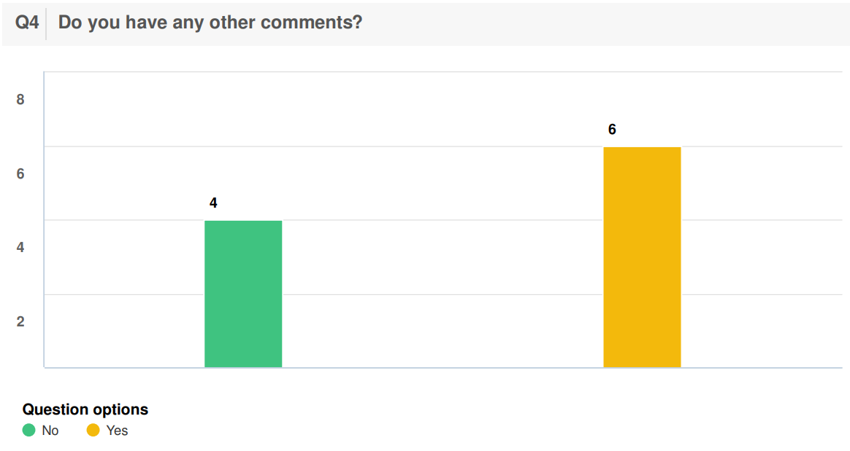

3.5 The additional comments from the 6 respondents were as follows:
- West Drive was originally within the Conservation Area before being removed as an act of political spite.
- The 2 houses at the entrance of West Drive on both side of the street should be included in the conservation area as they would qualify of significant architectural interest.
- The road does not have a high concentration of listed buildings, has no historical or architectural history left. Many of the houses have been modernised and there is no group of buildings with distinct physical identity. I do not see the benefit therefore for including this in a conservation area.
- I feel this area does not have the criteria above to meet a conservation zone. I.e., many of the houses are newly renovated and extended with no original architectural value or distinct physical identity or any historical value. So I would strongly disagree with this proposal as it does not fulfil any of the criteria.
- Both Bellfield Avenue and West Drive are representative of vernacular suburban architecture of the 1930s with a leafy relaxed atmosphere. There is a distinct physical identity and cohesiveness. The roads are often enjoyed by outsiders walking or running. The risk is that this identity will be increasingly destroyed by unsympathetic modernisation, greater hard-standing, more extensions and, worst, by demolishing and replacing the existing housing stock. The Conservation Area will help prevent that happening.
- This area has a distinct physical identity and cohesiveness. It was intended to have a variety of styles of architecture of the properties.

4 Conclusion
4.1 There is clear support for the proposed designation of the West Drive and Bellfield Avenue Conservation Area, although there is also some opposition. The majority of the respondents supported the proposed conservation area although there were some residents who believe that their houses should not be included on character grounds. An evaluation of the responses that opposed the designation will be undertaken and the border of the proposed conservation area may be altered depending on the merits of the suggested changes..

4.2 While rates of response for this consultation may be low in the context of a whole borough consultation, it does provide useful feedback on the proposed designation. As 99 households were directly contacted and 8 people who live in the proposed conservation area responded to the survey, and 4 people who live in the proposed conservation area submitted written responses, we have a response rate of 12.2%. It should also be noted that the page had high levels of engagement overall with 179 page visits and 61 informed visitors despite not receiving any multi-channel publicity.

